Technical Documentation for Koppeltaal 2 Server
Author: Theo Stolker & David Gestel
Version: 2.4

Introduction
The Koppeltaal 2 Server is based on InterSystems IRIS for Health, which comes with an out-of-the-box FHIR R4 server with OAuth2 support.
This document describes the additions that have been made to support Koppeltaal requirements.

Topics in this document
- Sending rest-hook Notifications based on FHIR Subscriptions
- Referential Integrity:
  - For create/update
  - For delete
- $expunge operation - This allows exercise the GDPR right-to-be-forgotten for a Patient
- ActivityDefinition – special behavior
- Checking for uniqueness of identifiers

Sending rest-hook Notifications based on FHIR Subscriptions

Overview
The following diagram shows how Notifications are sent based on create & update interactions processed by the FHIR Store:
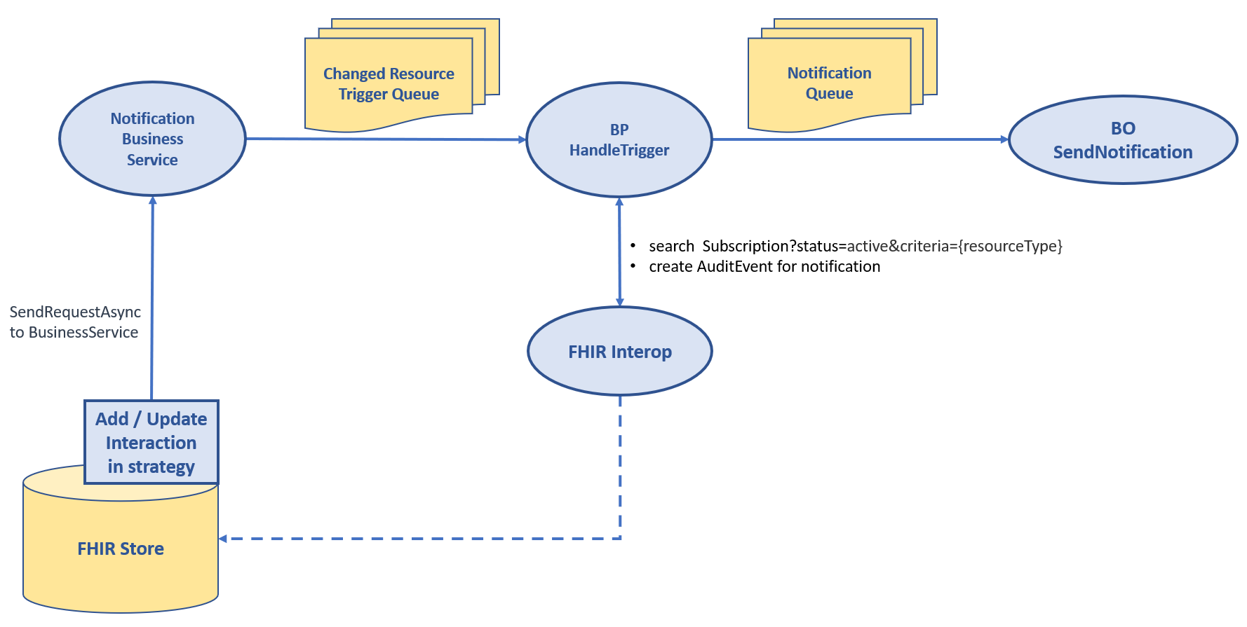
- When a Subscription is created or updated, it is validated against a set of rules described in next section. When all validations pass, the subscription is saved with status=active and criteria extended with the allowed resource-origins for the specified resource type.
- All create and update interactions are intercepted and will send an asynchronous trigger request to Notification Service, which in turn triggers the Business Process “HandleTrigger”
- BP HandleTrigger:
  - Gets active subscriptions for the created/updated resource type
  - For each matching subscription, it sends a Notification Requests via Business Operation “SendNotification”.
- BO SendNotification handles the sending of the Notification to the https endpoint
- BP HandleTrigger creates an AuditEvent for each Notification with error information for failed attempts

Validations
The following validations are performed on each Subscription being created or updated with status = “requested” or “active”:
Assertion | When fails, OperationOutcome.issue is added
Subscription.channel.type = "rest-hook"? | Only type 'rest-hook' is supported
Subscription.channel.endpoint is not empty? | Endpoint is required
Subscription.channel.endpoint starts with "https://" or "http://"? | Endpoint is not a valid http(s) url
Is Subscription.criteria for one of the supported resource types? | Suscription.criteria '%1' are not valid, must be one of Device, Task, Patient, CareTeam, Organization, ActivityDefinition, RelatedPerson, Practitioner, Endpoint, AuditEvent, Subscription
Is Subscription.criteria parameter allowed via lookup table ‘AllowedSubscriptions’ (see below) | Suscription.criteria refers to parameter '%1' which is not supported, supported are: %2
If Subscription.criteria parameter is ‘resource-origin’, does it refer to an authorized resource-origin for reading the resource type? | Suscription.criteria refers to resource-origin %1 which is not accessible, accessible are: %2
Is Subscription not unique, that is, does another Subscription resource with status=active and the same criteria for the same resource-origin already exist? | An active subscption with the same criteria already exists for this application

Allowed Search Parameters
In Lookup table “AllowedSubscriptions”, the allowed search parameter(s) must be configured. This is the initial set of allowed parameters:
Resource Type | Parameter(s)
ActivityDefinition | status,url,publisherId
CareTeam | status
Device | status
Endpoint | status
Organization | active
Patient | active
Practitioner | active
RelatedPerson | active
Subscription | status
Task | status,instantiates,instantiates.publisherId
All | resource-origin

Please note that subscribing with a status will result in no notification being sent when the resources status changes to a different status.

Final changes before saving the Subscription
When all validations pass, the subscription is saved, with the following final changes:
- When Subscription.status = requested, it is changed to status=active
- When criteria does not yet contain a filter for "resource-origin=", it is extended with a search parameter for the allowed resource-origins for reading the specified resource type.

Trigger request
For each created and updated resource, an asynchronous trigger request is sent to Business process HandleTrigger via the Notification Business service. The trigger request contains:
- The resource that was created / updated
- The assigned Resource.id
- The value for headers X-Trace-Id and X-Domain

Business Process HandleTrigger
Based on the trigger request, Business Process HandleTrigger reads the active Subscriptions for the resource type, and for each Subscription found, it evaluates all specified search criteria based on the created/updated resource instance, using the FHIRPath expression for the parameter definition in table HS_FHIRServer_Storage_Json.SearchColumn. When all criteria match, HandleTrigger sends and asynchronous NotificationRequest to the SendNotification Business Operation (BO).
In the current configuration, there are 10 instances of the SendNotification Business Operation running, allowing multiple Notifications to be sent in parallel, in order to avoid a slow server from bringing down Notification latency.
The SendNotification BO uses the HTTP Outbound Adapter to send the rest-hook Notification to the Subscriber. The following headers are set:
- All headers from Subscription.header
- Header 'X-ID-ONLY', with value {Resource.resourceType}/{Resource.id}
- Header 'X-SUBSCRIPTION-ID', with value of Subscription.id
- Header 'X-SUBSCRIPTION-REASON', with value of Subscription.reason
- Header 'X-Request-Id', with unique id of the request
- Header 'X-Trace-Id', with value of the X-Trace-Id header received from the caller.
Business Process HandleTrigger waits for all Notifications to be handled, whether it is successful or it fails, and creates an AuditEvent (except if the Notification is for an AuditEvent, because otherwise that would create an infinite loop) as described below.
Please note that there are no retries for failed Notifications, and failed Notification attempts do not change the Subscription.status.

AuditEvent resource for each Notification
For each Notification attempt, an AuditEvent with the following properties is created and stored:
- Extension http://koppeltaal.nl/fhir/StructureDefinition/resource-origin is set to the resource-origin for the subscriber
- Extension http://koppeltaal.nl/fhir/StructureDefinition/request-id is set to the unique id of the request
- Extension http://koppeltaal.nl/fhir/StructureDefinition/trace-id is set to the value of the X-Trace-Id header received from the caller.
- Extension http://koppeltaal.nl/fhir/StructureDefinition/correlation-id is set to the value of the 'X-CORRELATION-ID' from Subscription.header
- AuditEvent.type is set to {
"system": "http://terminology.hl7.org/CodeSystem/iso-21089-lifecycle",
"code": "transmit",
"display": "Transmit Record Lifecycle Event"
}
- AuditEvent.outcome is set from the HTTP Status code on the Notification reply
- For failed Notification attempts, AuditEvent.outcomeDesc is filled with a description of the error that occurred.
- AuditEvent.agent is set to as described in the specification, with agent.network set to the Subscription.channel.endpoint
- AuditEvent.source is set the same as for all other AuditEvent resources.
- The following entries are added to AuditEvent.entity:
  - A reference to the modified created or updated resource
  - A reference to the subscription resource in the role of Subscriber

Referential Integrity for create/update
When a resource is created or updated, all references must be to an existing resource. The references to be checked are registered in lookup table "ValidatedReferences" and checked during validation of the resource:
Resource Type | FHIRPath for each relation to be checked
ActivityDefinition | extension.where(url='http://koppeltaal.nl/fhir/StructureDefinition/KT2EndpointExtension').value
CareTeam | subject,participant.member,participant.onBehalfOf,managingOrganization
Endpoint | managingOrganization
Organization | partOf,endpoint
Patient | managingOrganization
Task | extension.where(url='http://vzvz.nl/fhir/StructureDefinition/instantiates').value,partOf,for,requester,owner

When no resource exists that matches a specified reference, the message “Unable to resolve local reference to resource '%1' is added to the OperationOutcome, and the validation fails.

Referential Integrity for delete
Also, when a resource is deleted, it must be ensured that no dependent resources exist. Dependent resources are found via the relations registered in the lookup table named “ReverseReferences”, which has the following content:
Resource Type | Checked dependent resources (specified as _revinclude search parameter)
ActivityDefinition | Task:instantiates
CareTeam | Task:owner
Device | ActivityDefinition:resource-origin,CareTeam:resource-origin,Endpoint:resource-origin,Organization:resource-origin,Patient:resource-origin,Practitioner:resource-origin,Subscription:resource-origin,Task:resource-origin
Endpoint | ActivityDefinition:endpoint
Organization | Organization:partof,Patient:organization,Endpoint:organization,CareTeam:organization,CareTeam:on-behalf-of
Patient | CareTeam:subject,Task:owner,Task:subject
Practitioner | Task:owner,Task:requester,CareTeam:participant
Task | Task:part-of

Please note that a few custom search parameters had to be added, in order to add support for checking references for dependencies that had no standard search parameter.

$expunge operation
A custom version of the $expunge operation has been added, with the following characteristics:
- It can be called with a Parameters resource (using HTTP method POST), or without payload (using HTTP method GET).
- The supported parameter names are:
  - cascadeDelete of type Boolean – when true, indicates the request to delete all dependent resources, default is false
  - reportOnly of type Boolean – when true (default), indicates that resources to be deleted must be reported, but no actual delete should happen.
- It only operates on instance level, not on type of history level
- It has support for cascadeDelete, allowing all dependent Task- and CareTeam resources to be deleted for a Patient, and dependent Tasks to be deleted for the Task. For other resource types, this is not supported.
- During cascade-delete, dependent resources are determined iteratively for each resource found via relations registered in the lookup table “ReverseReferences“ (which is also used for ensuring referential integrity during delete). Please note that the resource hierarchy can be messy, for example, for deleting Patient/1, we find a dependent CareTeam, which has a dependent Task (via Task.owner) with subject = “Patient/2”. In such case, an exception is thrown, and the process is aborted.
- If cascadeDelete is false, and there are dependent resources, the resource will not be expunged.
- When a resource is deleted, all versions of the resource will be physically deleted from the database. This is quite different from a normal delete, which creates a new version with deleted set to 1.

Example call
POST [base]/Patient/123/$expunge
Content-Type: application/fhir+json
{
"resourceType": "Parameters",
"parameter": [
{
"name": "cascadeDelete",
"valueBoolean": true
},
{
"name": "reportOnly",
"valueBoolean": false
}
]
}

Task ActivityDefinition reference – special behavior
The reference between Task and ActivityDefinition (Task.instantiatesCanonical) is of type canonical, and refers to the ActivityDefinition.url, optionally followed by a ‘|’ and version, like in https://xxx.nl/catalogue/4DKL|1.0. This points to a version 1.0 of the ActivityDefinition identified by url https://xxx.nl/catalogue/4DKL.

Validating uniqueness
When an ActivityDefinition resource is created or updated, it is ensured that there is not already an ActivityDefinition with the same combination of url and version.

Referential integrity – create and update
During create and update, the reference check needs to ensure that that specific version exists. If no version is specified, any ActivityDefinition with that url will match

Referential integrity – delete
When deleting an ActivityDefinition, the following must be checked:
- If the ActivityDefinition to be deleted has a specific version, ensure that no Task resources refer to this version explicitly
- If this is the last ActivityDefinition with the specific url, make sure no Task resources refer to this url without version.

search Task?_include=Task.instantiatesCanonical
The behavior of a search for Task?_include=Task.instantiatesCanonical is such that for each Task, the linked ActivityDefinition is included in the bundle, where for the ActivityDefinition included is:
- When no version is specified in the canonical reference, the ActivityDefinition with that url and the highest version is included
- When a version is specified, that ActivityDefinition with that url and specific version is included

search ActivityDefinition?_revinclude=Task.instantiatesCanonical
The behavior of a search for ActivityDefinition?_revinclude=Task.instantiatesCanonical, the following Tasks are included:
- If the ActivityDefinition has a version, all Tasks that refer to that this version
- When this ActivityDefinition has the highest version for this for this url, include all Task that refer to this ActivityDefinition without version

Checking for uniqueness of identifiers
Most resources supported by Koppeltaal can have one or more identifiers. Specifically for Device, the FHIR specification states that these identifiers are supposed to be unique.
Although for other resource types this is not explicitly stated, it make sense to ensure that each identifier is unique across the resources of a certain resource type. This logic has been added to the resource validation.

