Sending rest-hook Notifications based on FHIR Subscriptions

Overview
The following diagram shows how Notifications are sent based on create & update interactions processed by the FHIR Store:
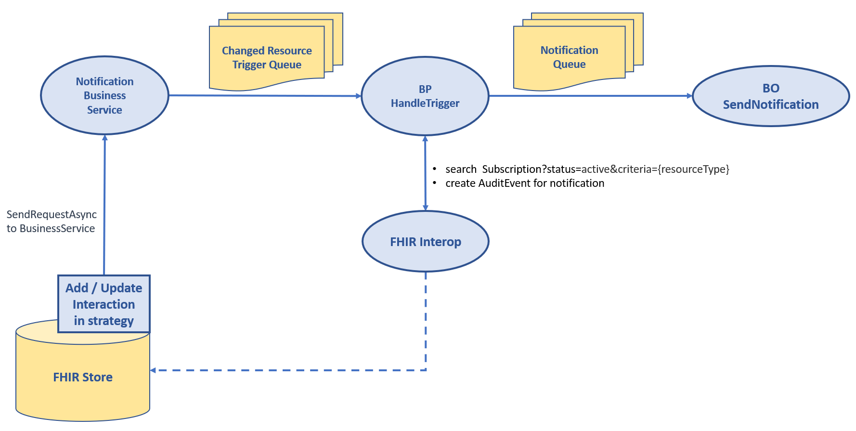
- When a Subscription is created or updated, it is validated against a set of rules described in next section. When all validations pass, the subscription is saved with status=active and criteria extended with the allowed resource-origins for the specified resource type.
- All create and update interactions are intercepted and will send an asynchronous trigger request to Notification Service, which in turn triggers the Business Process “HandleTrigger”
- BP HandleTrigger:
  - Gets active subscriptions for the created/updated resource type
  - For each matching subscription, it sends a Notification Requests via Business Operation “SendNotification”.
- BO SendNotification handles the sending of the Notification to the https endpoint
- BP HandleTrigger creates an AuditEvent for each Notification with error information for failed attempts

Validations
The following validations are performed on each Subscription being created or updated with status = “requested” or “active”:
Assertion | When fails, OperationOutcome.issue is added
Subscription.channel.type = "rest-hook"? | Only type 'rest-hook' is supported
Subscription.channel.endpoint is not empty? | Endpoint is required
Subscription.channel.endpoint starts with "https://" or "http://"? | Endpoint is not a valid http(s) url
Is Subscription.criteria for one of the supported resource types? | Suscription.criteria '%1' are not valid, must be one of Device, Task, Patient, CareTeam, Organization, ActivityDefinition, RelatedPerson, Practitioner, Endpoint, AuditEvent, Subscription
Is Subscription.criteria parameter allowed via lookup table ‘AllowedSubscriptions’ (see below) | Suscription.criteria refers to parameter '%1' which is not supported, supported are: %2
If Subscription.criteria parameter is ‘resource-origin’, does it refer to an authorized resource-origin for reading the resource type? | Suscription.criteria refers to resource-origin %1 which is not accessible, accessible are: %2
Is Subscription not unique, that is, does another Subscription resource with status=active and the same criteria for the same resource-origin already exist? | An active subscption with the same criteria already exists for this application

Allowed Search Parameters
In Lookup table “AllowedSubscriptions”, the allowed search parameter(s) must be configured. This is the initial set of allowed parameters:
Resource Type | Parameter(s)
ActivityDefinition | status
ActivityDefinition | url
CareTeam | status
Device | status
Endpoint | status
Organization | active
Patient | active
Practitioner | active
RelatedPerson | active
Subscription | status
Task | status
all | resource-origin

Please note that subscribing with a status will result in no notification being sent when the resources status changes to a different status.

Final changes before saving the Subscription
When all validations pass, the subscription is saved, with the following final changes:
- When Subscription.status = requested, it is changed to status=active
- When criteria does not yet contain a filter for "resource-origin=", it is extended with a search parameter for the allowed resource-origins for reading the specified resource type.

Trigger request
For each created and updated resource, an asynchronous trigger request is sent to Business process HandleTrigger via the Notification Business service. The trigger request contains:
- The resource that was created / updated
- The assigned Resource.id
- The value for headers X-Trace-Id and X-Domain

Business Process HandleTrigger
Based on the trigger request, Business Process HandleTrigger reads the active Subscriptions for the resource type, and for each Subscription found, it evaluates all specified search criteria based on the created/updated resource instance, using the FHIRPath expression for the parameter definition in table HS_FHIRServer_Storage_Json.SearchColumn. When all criteria match, HandleTrigger sends and asynchronous NotificationRequest to the SendNotification Business Operation (BO).
In the current configuration, there are 10 instances of the SendNotification Business Operation running, allowing multiple Notifications to be sent in parallel, in order to avoid a slow server from bringing down Notification latency.
The SendNotification BO uses the HTTP Outbound Adapter to send the rest-hook Notification to the Subscriber. The following headers are set:
- All headers from Subscription.header
- Header 'X-ID-ONLY', with value {Resource.resourceType}/{Resource.id}
- Header 'X-SUBSCRIPTION-ID', with value of Subscription.id
- Header 'X-SUBSCRIPTION-REASON', with value of Subscription.reason
- Header 'X-Request-Id', with unique id of the request
- Header 'X-Trace-Id', with value of the X-Trace-Id header received from the caller.
Business Process HandleTrigger waits for all Notifications to be handled, whether it is successful or it fails, and creates an AuditEvent (except if the Notification is for an AuditEvent, because otherwise that would create an infinite loop) as described below.
Please note that there are no retries for failed Notifications, and failed Notification attempts do not change the Subscription.status.

AuditEvent resource for each Notification
For each Notification attempt, an AuditEvent with the following properties is created and stored:
- Extension http://koppeltaal.nl/fhir/StructureDefinition/resource-origin is set to the resource-origin for the subscriber
- Extension http://koppeltaal.nl/fhir/StructureDefinition/request-id is set to the unique id of the request
- Extension http://koppeltaal.nl/fhir/StructureDefinition/trace-id is set to the value of the X-Trace-Id header received from the caller.
- Extension http://koppeltaal.nl/fhir/StructureDefinition/correlation-id is set to the value of the 'X-CORRELATION-ID' from Subscription.header
- AuditEvent.type is set to {
"system": "http://terminology.hl7.org/CodeSystem/iso-21089-lifecycle",
"code": "transmit",
"display": "Transmit Record Lifecycle Event"
}
- AuditEvent.outcome is set from the HTTP Status code on the Notification reply
- For failed Notification attempts, AuditEvent.outcomeDesc is filled with a description of the error that occurred.
- AuditEvent.agent is set to as described in the specification, with agent.network set to the Subscription.channel.endpoint
- AuditEvent.source is set the same as for all other AuditEvent resources.
- The following entries are added to AuditEvent.entity:
  - A reference to the modified created or updated resource
  - A reference to the subscription resource in the role of Subscriber

